MILESTONE 1
Faculty Information Storage System
ERD & Relational Database Schema

Subject | Database Systems
Instructor | Ali Hassan
Group Members | Muhammad Ali Bilal, Muhammad Gulsher
Semester | BSSE-A
Submission Date | April 26, 2025
Milestone | 1 — ERD & Relational Schema
SECTION 1
Project Overview
The Faculty Information Storage System is designed to replace manual and spreadsheet-based faculty data management in educational institutions. The system provides a centralized, database-driven solution for storing, retrieving, and managing faculty information efficiently.
This document covers Milestone 1: the Entity-Relationship Diagram (ERD) and full Relational Database Schema for the system.
SECTION 2
Entity-Relationship Diagram
The diagram below illustrates all entities, their attributes, primary/foreign keys, and the relationships between them. Core tables are shown in blue; supporting tables are displayed in lighter tones.

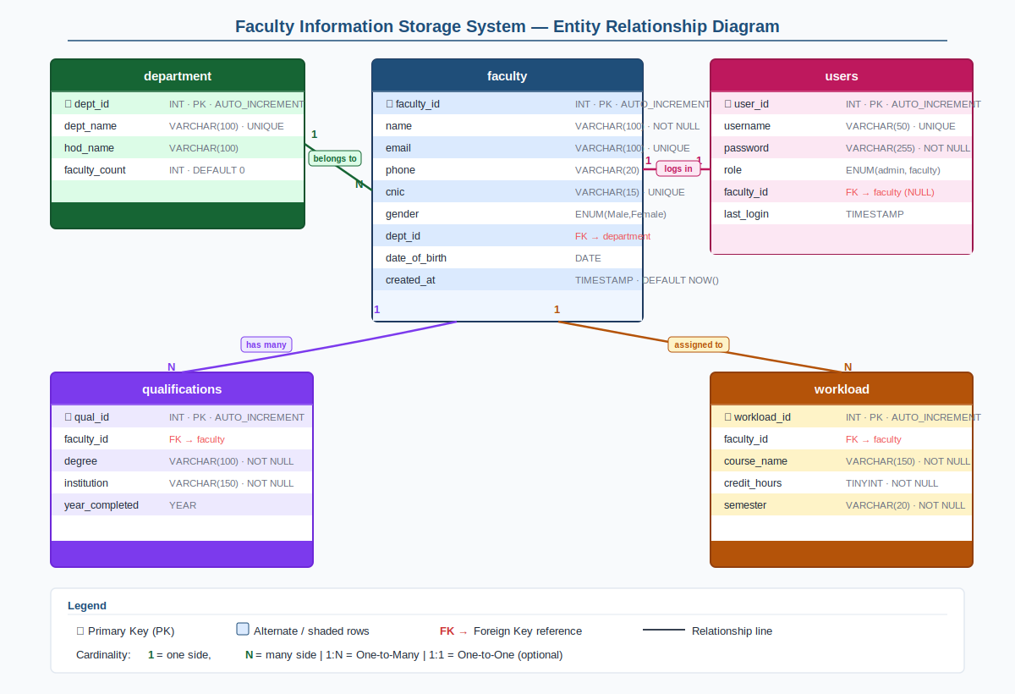
Figure 1 — Entity-Relationship Diagram, Faculty Information Storage System
SECTION 3
Relational Database Schema
The schema consists of two core tables and supporting authentication tables, all using MySQL InnoDB for referential integrity support.

3.1 faculty
Core table storing all faculty member records including personal, academic, and professional details.

Attribute | Data Type | Constraint | Description
faculty_id | INT | PK, AUTO_INCREMENT | Unique faculty identifier
name | VARCHAR(100) | NOT NULL | Full name of faculty member
email | VARCHAR(100) | NOT NULL, UNIQUE | Official email address
phone | VARCHAR(20) | NULL | Contact phone number
cnic | VARCHAR(15) | NOT NULL, UNIQUE | National ID number
gender | ENUM('Male','Female') | NOT NULL | Gender of faculty member
date_of_birth | DATE | NULL | Date of birth
created_at | TIMESTAMP | DEFAULT NOW() | Record creation timestamp

3.2 department
Stores department information. Each faculty member is associated with one department.

Attribute | Data Type | Constraint | Description
dept_id | INT | PK, AUTO_INCREMENT | Unique department identifier
dept_name | VARCHAR(100) | NOT NULL, UNIQUE | Name of the department
hod_name | VARCHAR(100) | NULL | Head of Department name
faculty_count | INT | DEFAULT 0 | Total faculty in department

3.3 qualifications
Stores academic qualifications of faculty members. A faculty member may have multiple qualifications.

Attribute | Data Type | Constraint | Description
qual_id | INT | PK, AUTO_INCREMENT | Unique qualification ID
faculty_id | INT | FK → faculty(faculty_id) | Associated faculty member
degree | VARCHAR(100) | NOT NULL | Degree title (e.g., PhD, MSc)
institution | VARCHAR(150) | NOT NULL | Name of awarding institution
year_completed | YEAR | NULL | Year of completion

3.4 workload
Tracks courses assigned to each faculty member per semester.

Attribute | Data Type | Constraint | Description
workload_id | INT | PK, AUTO_INCREMENT | Unique workload record ID
faculty_id | INT | FK → faculty(faculty_id) | Assigned faculty member
course_name | VARCHAR(150) | NOT NULL | Name of the course
credit_hours | TINYINT | NOT NULL | Credit hours for the course
semester | VARCHAR(20) | NOT NULL | Semester (e.g., Fall 2025)

3.5 users (Authentication)
Handles login authentication for system administrators and faculty users.

Attribute | Data Type | Constraint | Description
user_id | INT | PK, AUTO_INCREMENT | Unique user identifier
username | VARCHAR(50) | NOT NULL, UNIQUE | Login username
password | VARCHAR(255) | NOT NULL | Hashed password
role | ENUM('admin','faculty') | NOT NULL | System access role
faculty_id | INT | FK → faculty(faculty_id), NULL | Linked faculty record (if any)
last_login | TIMESTAMP | NULL | Last login timestamp
SECTION 4
Relationships & Cardinality

Relationship | Type | Description
faculty → department | Many-to-One (N:1) | Many faculty members belong to one department; each faculty has exactly one department.
faculty → qualifications | One-to-Many (1:N) | A faculty member may hold multiple qualifications; each qualification belongs to one faculty.
faculty → workload | One-to-Many (1:N) | A faculty member may be assigned many courses; each workload record belongs to one faculty.
users → faculty | One-to-One (opt.) | A user account may optionally be linked to one faculty record for portal login.
SECTION 5
Integrity Constraints
- Primary Keys — every table uses a surrogate INT AUTO_INCREMENT primary key.
- Foreign Keys — enforced via MySQL with ON DELETE RESTRICT to prevent orphaned records.
- UNIQUE — email and cnic in faculty, dept_name in department, username in users are all unique.
- NOT NULL — critical fields (name, email, cnic, role, degree, course_name) cannot be empty.
- ENUM — gender, role fields are restricted to predefined valid values.
- DEFAULT — timestamps use DEFAULT NOW() for automatic record-keeping.
SECTION 6
Normalization
The schema is designed to conform to Third Normal Form (3NF):
- 1NF — All attributes are atomic; no repeating groups or multi-valued fields.
- 2NF — All non-key attributes are fully dependent on the entire primary key (no partial dependencies).
- 3NF — No transitive dependencies; every non-key attribute depends only on the primary key.

